**Step1**: Not able to connected to the client **“redis-cli**”.

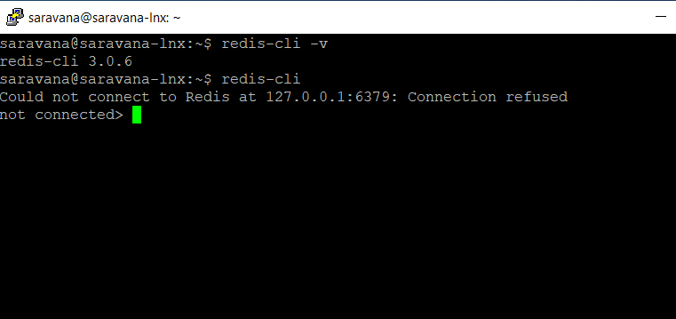

**Step2**: Next started my “**redis-server**”

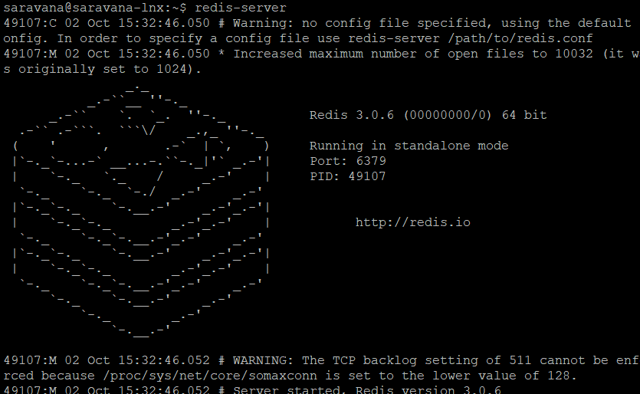

**Step3**: Now, I could connect to **the redis server from redis-client.**

